**Condominium 70 sqm. Level 4, Studio.   
Jomtien Beach Front. Na Jomtien Soi 19.   
New Decorated. Swimming Pool and Sea View.  
Include : Furniture, Air-condition, TV, Refrigerator.**

**Rent : 20,000 Baht/Month  
Sale : 3,200,000 Bath**

**Call : 089-815-0223**

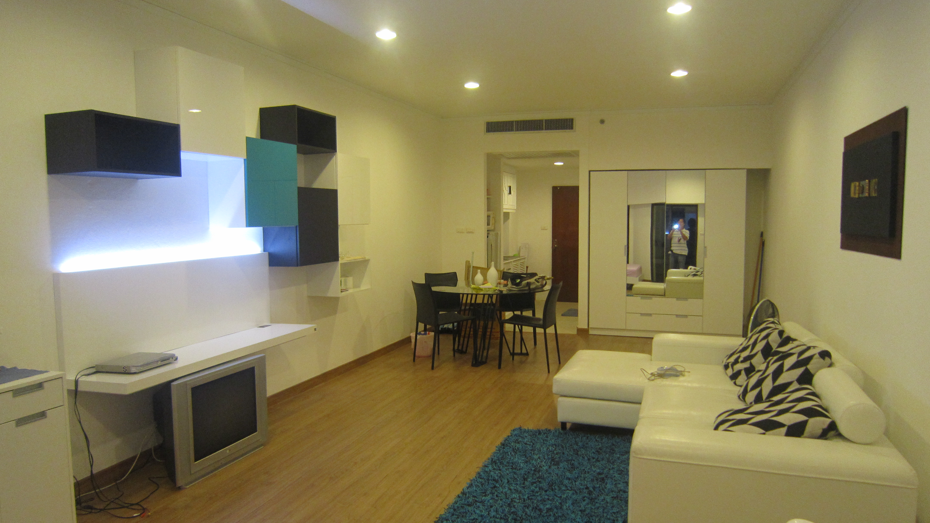

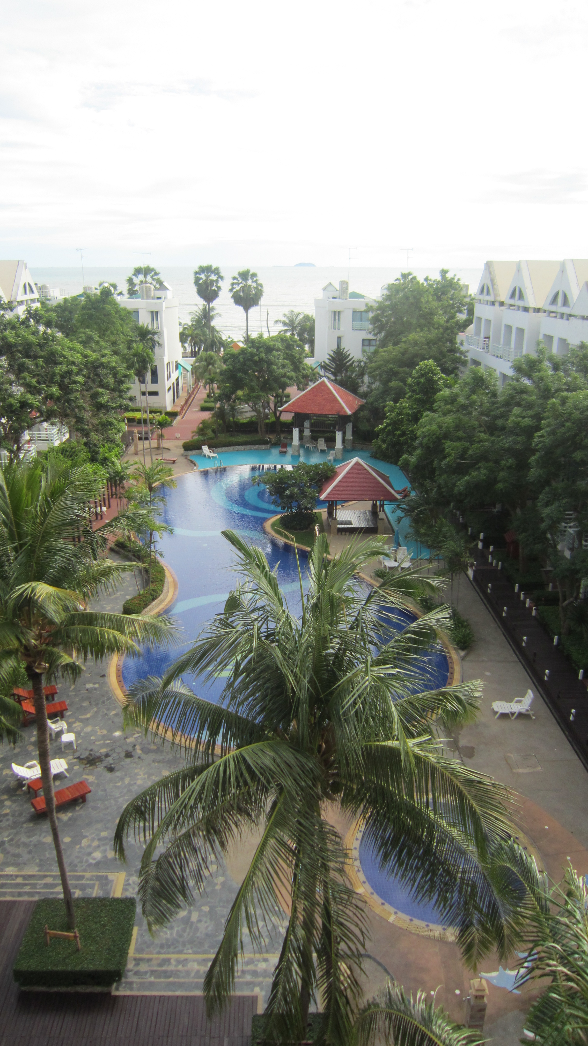

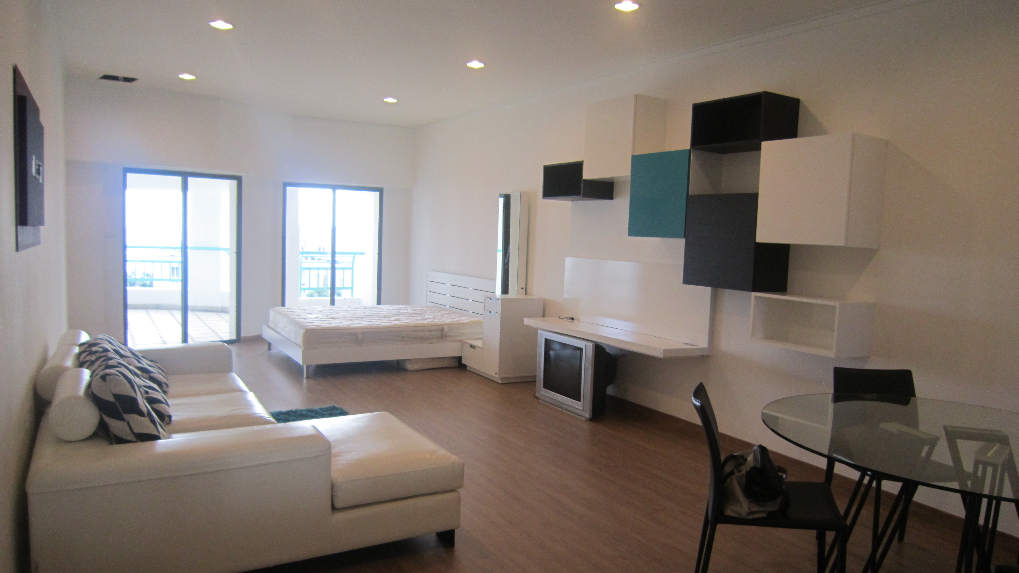

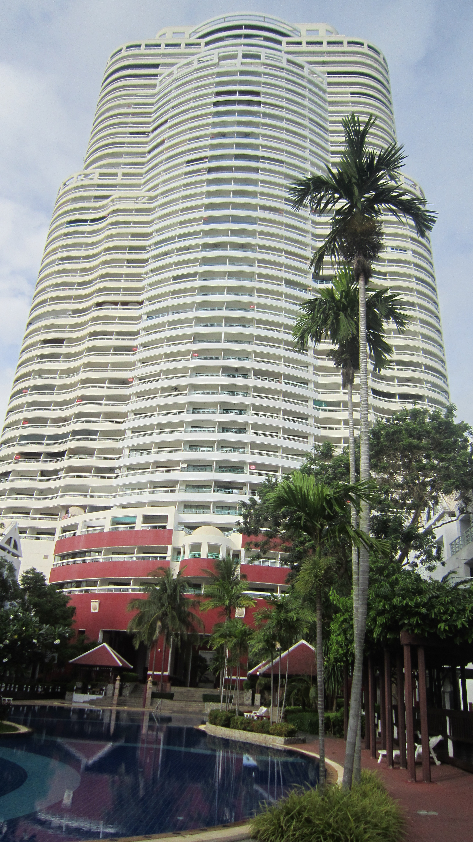

Call : 089-815-0223